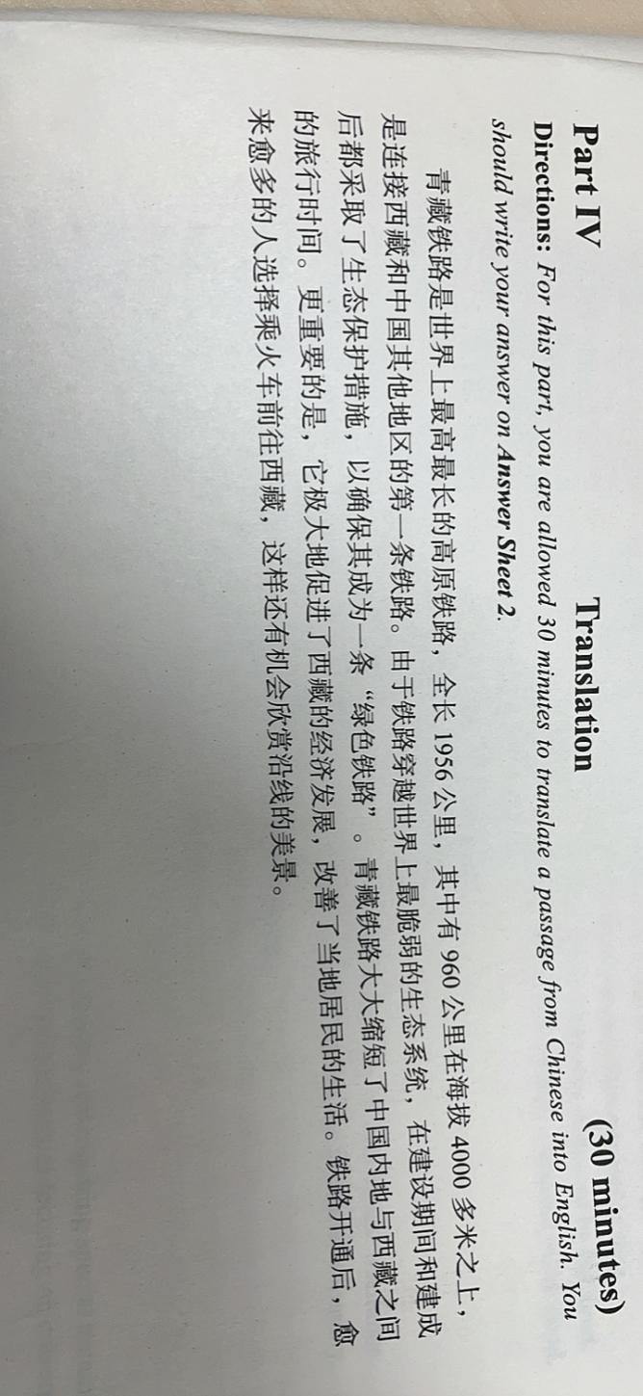The Qingzang railway is the longest and highest (plateau)railway in the world. It covers 1956 kilometers, among which 960 kilometers(of which) of railway is set above 4000 meters (above sea level)height and it is the first Chinese railway that connects Tibet and other areas in China. Since the railway goes through(traverse) the most fragile ecosystem in the world, methods(measure) to protect the ecosystem was adopted in and after the construction, in order to ensure that it becomes an environmentally friendly railway. Qingzang railway largely shortens the travel time between Chinese inner areas(mainland) and Tibet. More importantly, it stimulates the economical development in Tibet and improve local’s life quality to a large extent. After it was put into use(the opening of the railway), an increasing number of people choose to take the train to Tibet, in which they have chance to appreciate the beautiful scene along the way.